MODELING AND CONTROL OF AN ANTI-LOCK BRAKING SYSTEM
Ntsako K. Manyike
School of Electrical & Information Engineering, University of the Witwatersrand, Private Bag 3, 2050, Johannesburg, South Africa
Abstract: The Abstract goes herepaper.
Key words: Four to six key words in alphabetical order, separated by commas.

Introduction
The technology of vehicles, especially cars all over the world is continuously evolving. Along with the many advances in the car manufacturing industry, the safety requirement for cars is of paramount importance. The techniques applied to various cars have already improved system stability and passenger safety with the use of several significant control systems, such as anti-lock braking systems (ABS), active suspension systems, traction control systems etc.
ABS is a system on motor vehicles which prevents the wheel from locking while braking. The purpose of this system is to allow the driver to maintain steering control under heavy breaking and in some situations to shorten braking distance and time. When brakes lock up on wet and slippery roads during a panic stop the driver might lose steering control and the vehicle can spin.
There have been some integrated studies that combined the aforementioned subsystems in order to further enhance vehicle dynamic efficiency. For example, the concept of integrating ABS with active suspension has been introduced and investigated in the work of \cite{Alleyne:1997}. Many theories and design methods for ABS and active suspension systems have been proposed individually over the years.

BACKGROUND

Type sizes and type faces
If you are using a desktop publishing package other than Wor possible. The type sizes and fonts are specified in Error: Reference source not found. Please use Times New Roman font, or other Rom been set.

Format
The paper size is A4 (210 mm × 297 mm). The text length electronically.

Title and subtitle
The title at the top of the first page should be capitalised

SYSTEM DESCRIPTION
Number headings and sub-headings as shown. Number the Introduction but do not number the Acknowledgment or References.

Mathematical model
First level headings, starting with INTRODUCTION and by one 10-point line spacing.

Subheadings (second and third level headings)
Second level headings: These should be sequenti be followed by one 10-point line spacing.
Third level headings: These should be in an ital above.

Body
The body of the paper should be
pacing.

SYSTEM Modeling
The primary objective of designing an ABS controller is to improve the braking time of the car. The car has an initial longitudinal velocity, v(t₀) = 120 km/h. When the brakes of the car are applied the car has to come to a stop at a time t_{f} i.e. v(t_{f}) = 0 km/h. The purpose of the ABS and active suspension modelling is to minimise t_{f} whilst maintaining car steering and improving passenger comfort during breaking.

Mathematical model
The mathematical model of the ABS model along with the suspension system is developed. The active suspension system has already been modelled in \cite{Manyike:2011} and the results will be used here.
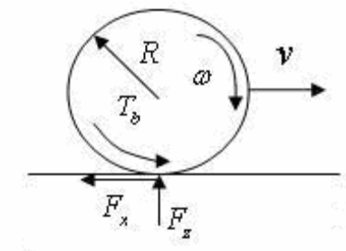
Figure 1: Quarter car forces and torques
#Talk about the slip here and tie it to the math, for the complete picture see \cite{Nyandoro1:2011}. The model consists of a single wheel of mass m_{u} and radius R attached to a mass, m_{s}. As the wheel rotates, in the direction of the velocity v driven by the wheels moment of inertia I, a tyre reaction force F_{x} is generated by the friction between the tyre surface µ. The tyre reaction force will generate a torque that initiates a rolling motion of the wheel causing an angular velocity ω. A brake torque τ_{b} applied to the wheel will act against the spinning of the wheel causing a negative angular acceleration.

Applying Newton’s laws of motion on the quarter car braking model results:

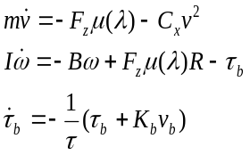 (1)
Where F_{z} is the total normal force acting on all wheels of the vehicle, and C_{x} is the vehicle aerodynamic friction coefficient. B is the wheel bearing coefficient and K_{b} is the braking gain. The coefficient of friction µ(λ) is a non-linear function of the wheel slip ratio λ. In the braking condition the slip ratio is defined as:
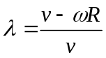 (2)
Equation (2) describes the normalised difference between the vehicle speed, v and the wheel perimeter Rω. The coefficient of friction µ between the tyre and road surface depends on the tyre-road conditions and the value of wheel slip λ. This value can be worked out experimentally for different road surfaces. The results of which are approximated for dry asphalt, wet asphalt, and icy roads and depicted pictorially in Figure 1. From (2) and Fig. 1 it is observed that λ = 0 represents the free rolling wheel condition where no friction force F_{x} is exerted. While λ = 1 corresponds to a wheel that is locked (ω = 0). 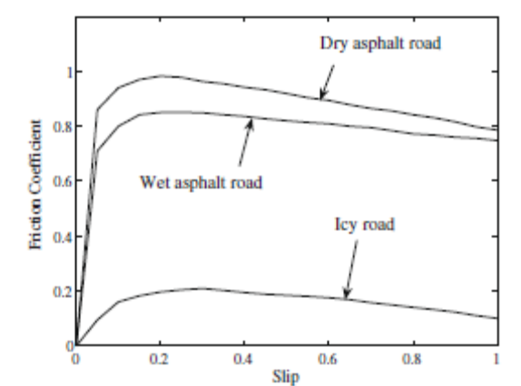
Figure 2: Typical tire longitudinal friction µ vs λ curves for three types of roads.
From Figure 2 it can be seen that the value µ(λ) varies over a wide range of λ values. The peak friction coefficient µ₀ occurs at different values of λ for the different roads. For higher slip values, the friction coefficient will decrease until the wheel is locked. The function µ(λ) can be approximated by the function:
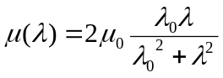(3)
Where µ₀ is the maximum friction coefficient between the tyre and the road, λ₀ is the optimal slip ratio which can yield the peak friction value for a specified road. Since µ₀= µ(λ₀) then the goal of slip control is to maintain the braking slip value always close or equal to it’s optimal value λ₀ \cite{Pedro:2009}. This reduces the braking distance and ensures the vehicle directional stability during braking.
The normal force Fz on the wheel of the car is the sum of the static and the dynamic weight of the vehicle. The dynamic weight is mainly determined by the longitudinal acceleration of m_{s}. The goal of incorporating the effects af an active-suspension system with the ABS modelling and design is so that Fz change in phase with the brake torque τ_{b} \cite{ Alleyne:1997 }. This relationship will ensure that µ(λ₀) occurs at when the brake torque is at it’s peak thus resulting in the optimum road brake force. From the complete model, see \cite{Nyandoro1:2011}:
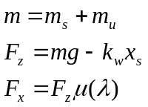 (4)
Where k_{w} is the spring constant of the linearized tire model.

0state-space analysis
Figures, illustrations, tables and graphs s

State-space representation
Equations (1) – (4) are non-linear equations. They can be represented in a state-space model as a multi-input multi-output (MIMO) system \cite{Nyandoro2:2011}. The states are chosen as x = [x₁ x₂ x₃ x₄ x₅ x₆]^{T}, x₁= v,x₂ = ω, x₃ = x_{s}, x₄ = x_{u}, x₅ = Dx_{s} and x₆ = Dx_{u} with D=d/dt.
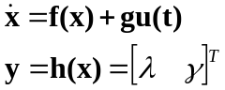 (5)
Where
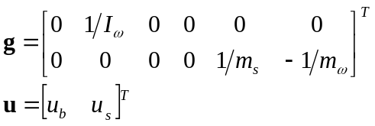 (6)
And λ is as in Equation 2 and γ = x_{s} – x_{u} = x₄ – x₃, i.e. the suspension travel from the model developed in \cite{Manyike:2011}.

Input-Output feedback linearisation
In a given a system such as the one presented by equations (5) and (6), it is difficult for the output y(t) to track a predetermined trajectory, y_{d}(t)while keeping all the n states bounded. This is due to the indirect relationship of the output, v, to the input force that forces it to 0, τ_{b}. Input-output feedback linearization aims to relate the output with the input via a state \cite{Nyandoro2:2011}.
This is achieved by differentiating the output equation until y is directly related to the input u. This gives a new linear state equation:
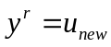 (7)
With r being the relative degree i.e. the number of differentiations. Usually r < n (n= number of states) meaning that some state dynamics are hidden by the linearization process. This relationship makes it easy to apply control-law to synthesise a tracking controller.
To relate the output, y.

Controller design
A controller can now be synthesised from the linearised state-space presented in the previous section.

Figures
Figures
Photo Editor.

Tables
Table
fashion to produce a TIFF file of suitable resolution.

Input-State Linearization

General

Use a paper.

Abbreviations and Acronyms
Define not “Webers/m²” .

Editorial Policy
Do not obtain it.

Paper Submission
The electronic Conclusion
A conclusion may review the main points of the paper, but do not replicate the abstract as the conclusion.
References
- G.H. Muller and C.F. Landy. “Detection of broken rotor bars, Part 1 – new theory”, SAIEE Transactions, Vol. 95, No. 1, pp. 7-18, March 2003.
- L. Finn, R. Mulholland and G.J. Gibbon. “Design and implementation of a prototype computer based rehabilitation device for the lower extremities”, SAIEE Transactions, Vol. 95, No. 1, pp. 29-32, March 2003.
- P. Vas. “Simulation and monitoring of induction motors with rotor asymmetry”, Proceeding of the 6th International Conference on Electrical Machines, Manchester, pp. 435-439, May 1992.
- A.V. Oppenheim and R.W. Schafer. Discrete-time signal processing, Prentice-Hall Inc., USA, first edition, chapter 3, pp. 82-112, August 1989.

